**Project Report: Milestone 1**

Name: Alyssa Ainna Manlapig

Class: CST-126

Date: Feb 28, 2019

**Description:**

Created a user registration page for my blog. Minimal design, but functions properly.

Asks for Email, First Name, Last Name, Username, and Password.

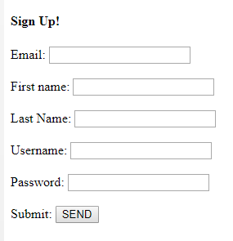

Upon submission, sends form data to Miliestone1 schema/users table.   
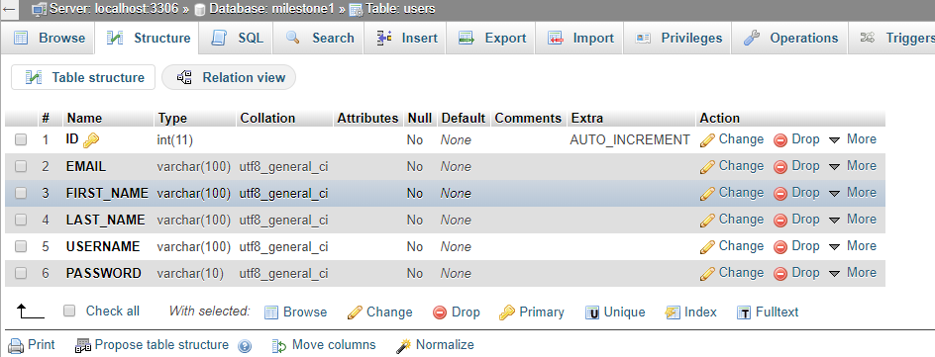

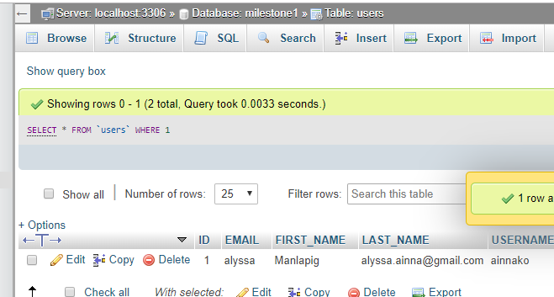

**Modules & Files**:

Milestone1 zip folder will include: RegForm.html , pageHandler.php

